**Experiment -1.**

**Student Name: Prabha Sinha UID: 22BDO10078**

**Branch: CSE (Devops) Section/Group: 22BCD-1/B**

**Semester: 4 Date of Performance: 15/1/24**

**Subject Name : Git and GitHub Subject Code: 22CSH-293**

**1. Aim/Overview of the practical:** Installation of Git and Github Repository creation

**2. Task to be done:** Git installation in PC(Selecting features which going to install) and going to create repository on github web interface.

**3. Steps :**

1) On Browser write Git install, after enter Git Download website will get available,click on it.

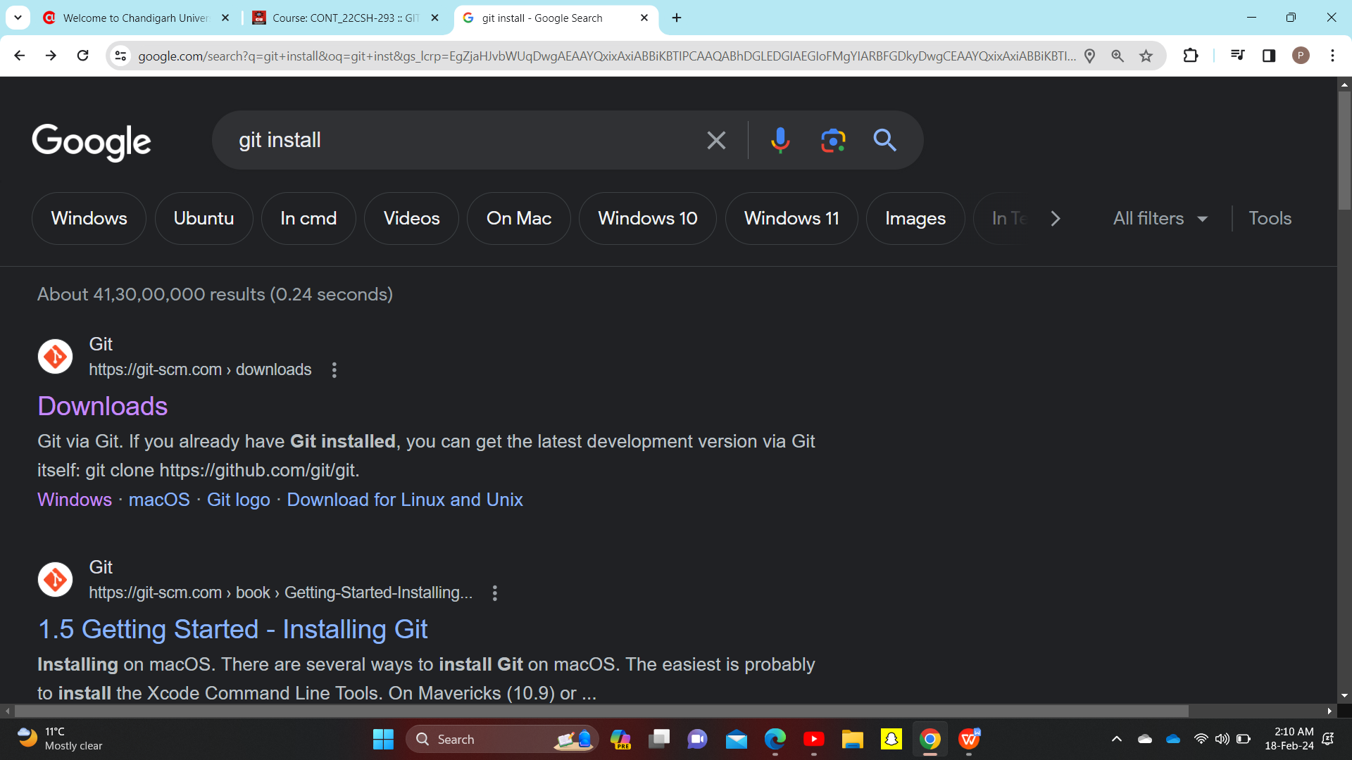

2)One new page get open in which Downloads For Windows option(as my pc has window OS) is available, click on it.

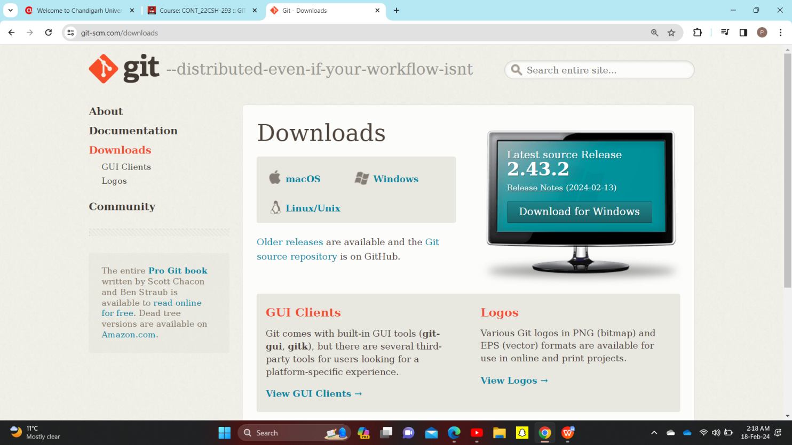

It get downloaded like a normal software.

3)Run the installer

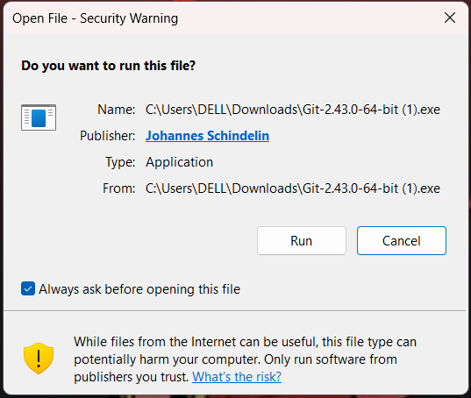

1. GNU General Public Lincense will appear , after reading it click next.

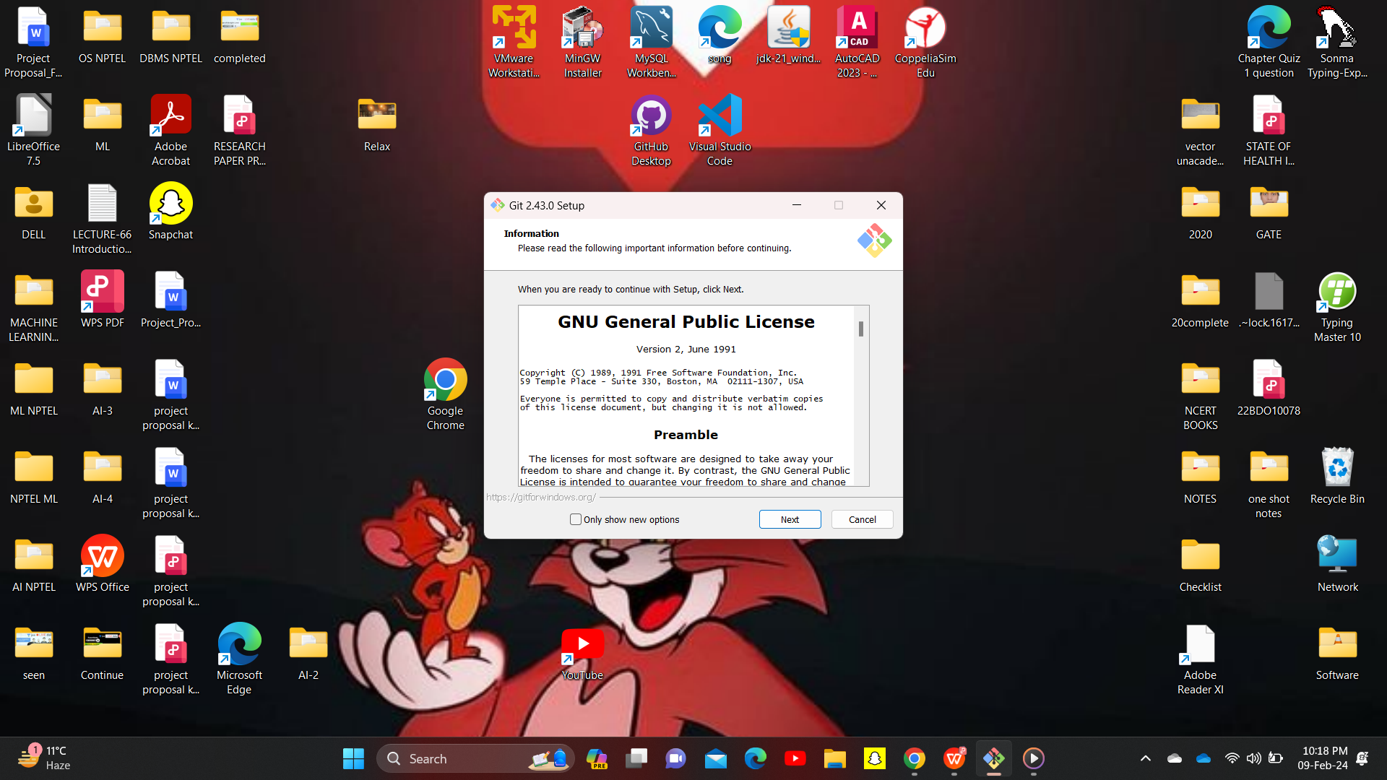

Some of the points from GNU preamble is

1. share and change(modify) free software--to make sure the software is free(free means freedom to distribute copies of free software (and charge for this service if you wish)), for all its users.
2. No warranty: if user want to test code after modifying they can do at their own risk,if the software is modified by someone else and passed on, Owner of Git want its recipients to know that what they have is not the original, so that any problems introduced by others will not reflect on the original authors' reputations.
3. Next tab come for select destination location. Here it is asking for where Git to be installed,

By default it is in c drive program files, but it ask if we want to select different folder.

And it also show how much minimum space is going to required.

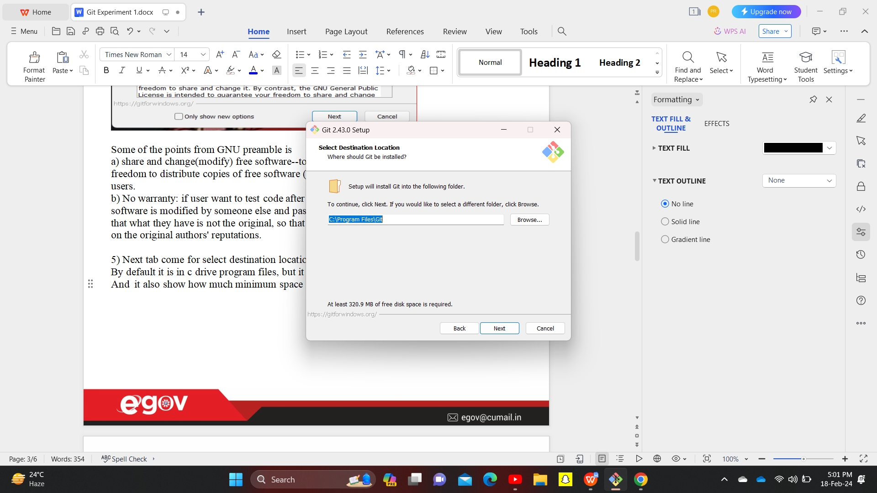click on next.

1. Select Components tab will open ,here which components should be installed among available components need to mark right.

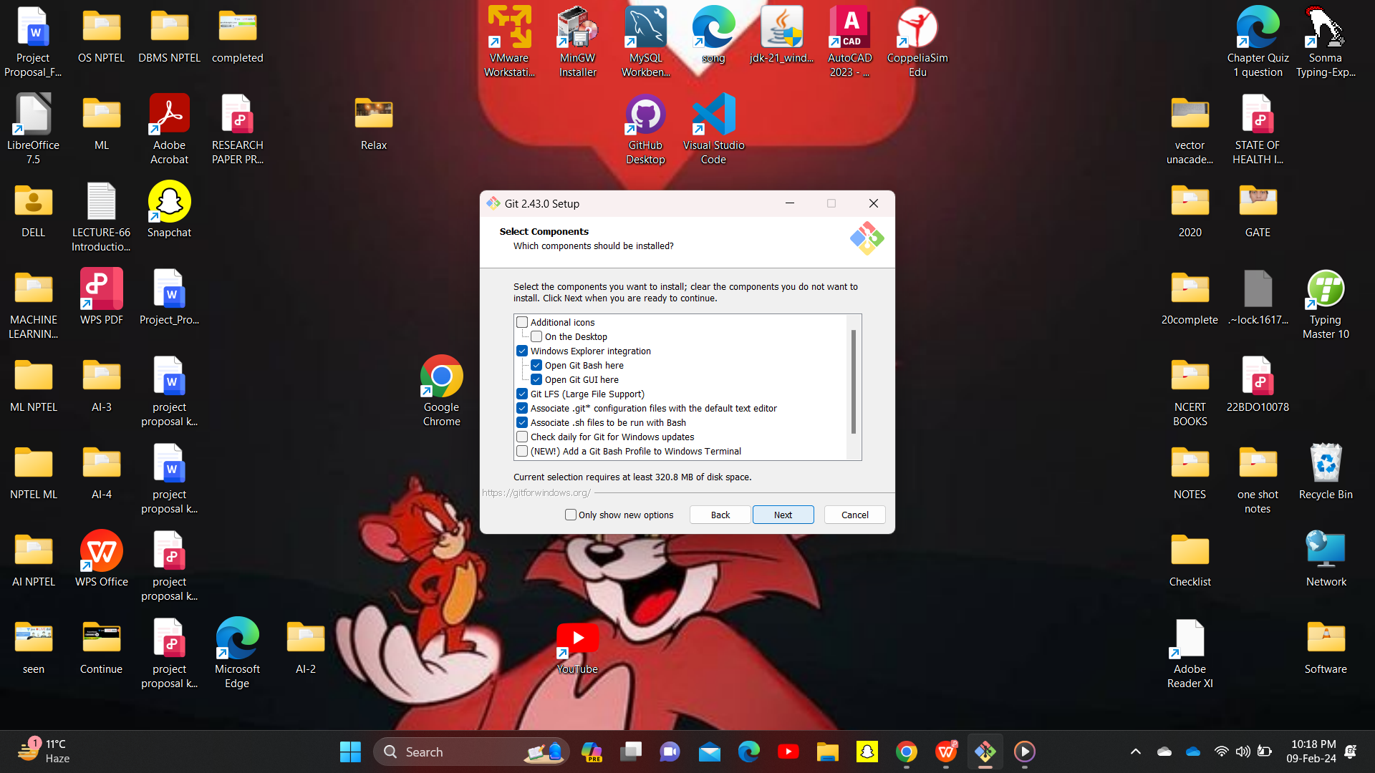Click on next.

7)

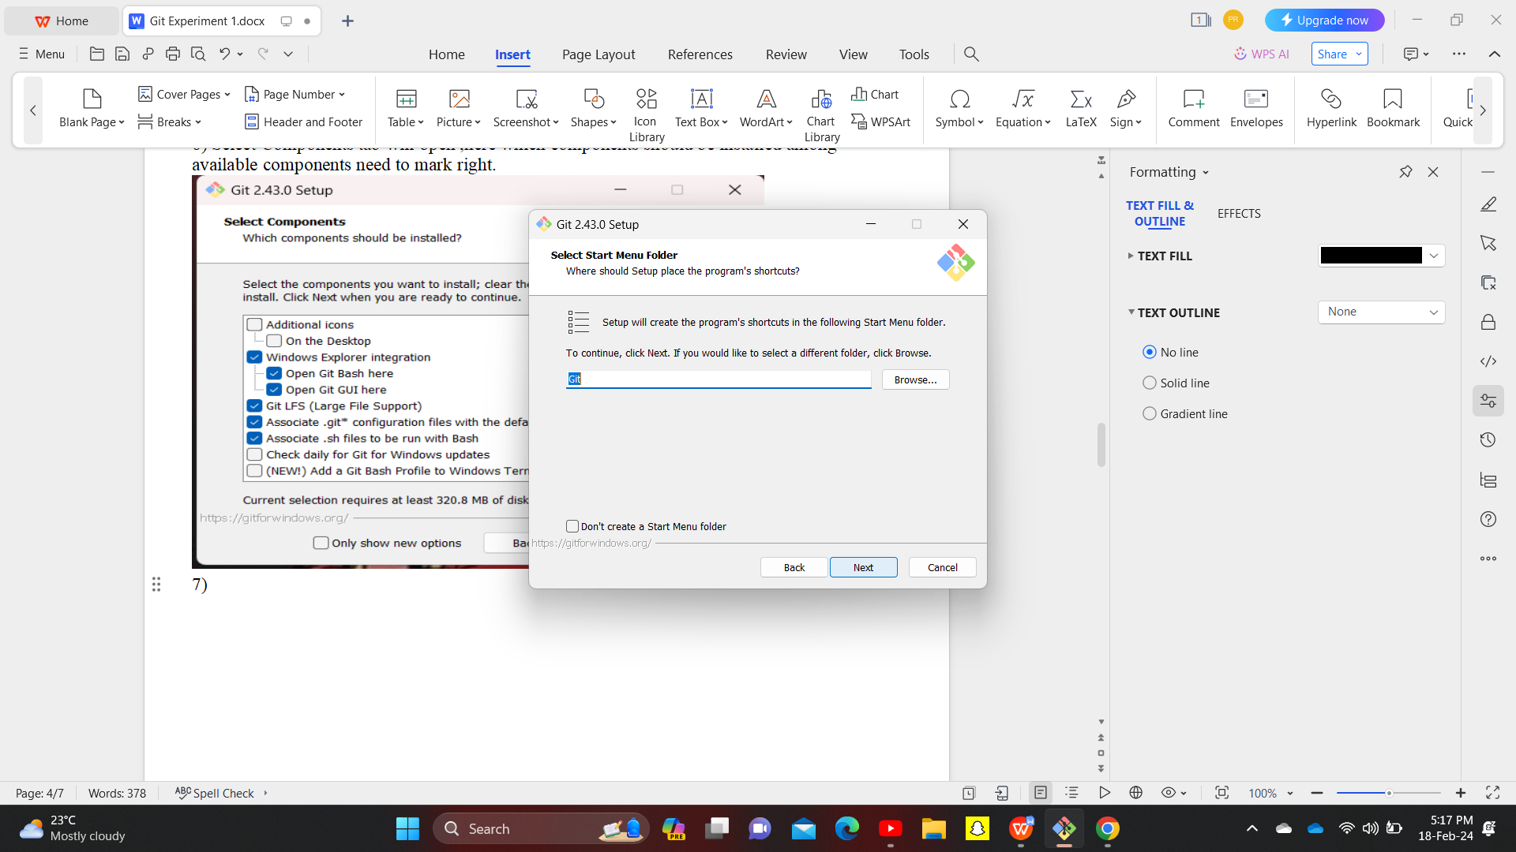Click on next.

8) Default editor of git is vim but Git GUI editor is recommended.

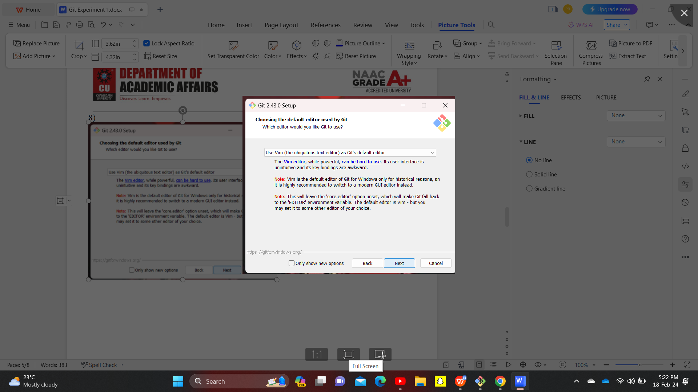

1. Adjusting the name of initial branch in new repository.By default it is “master”.

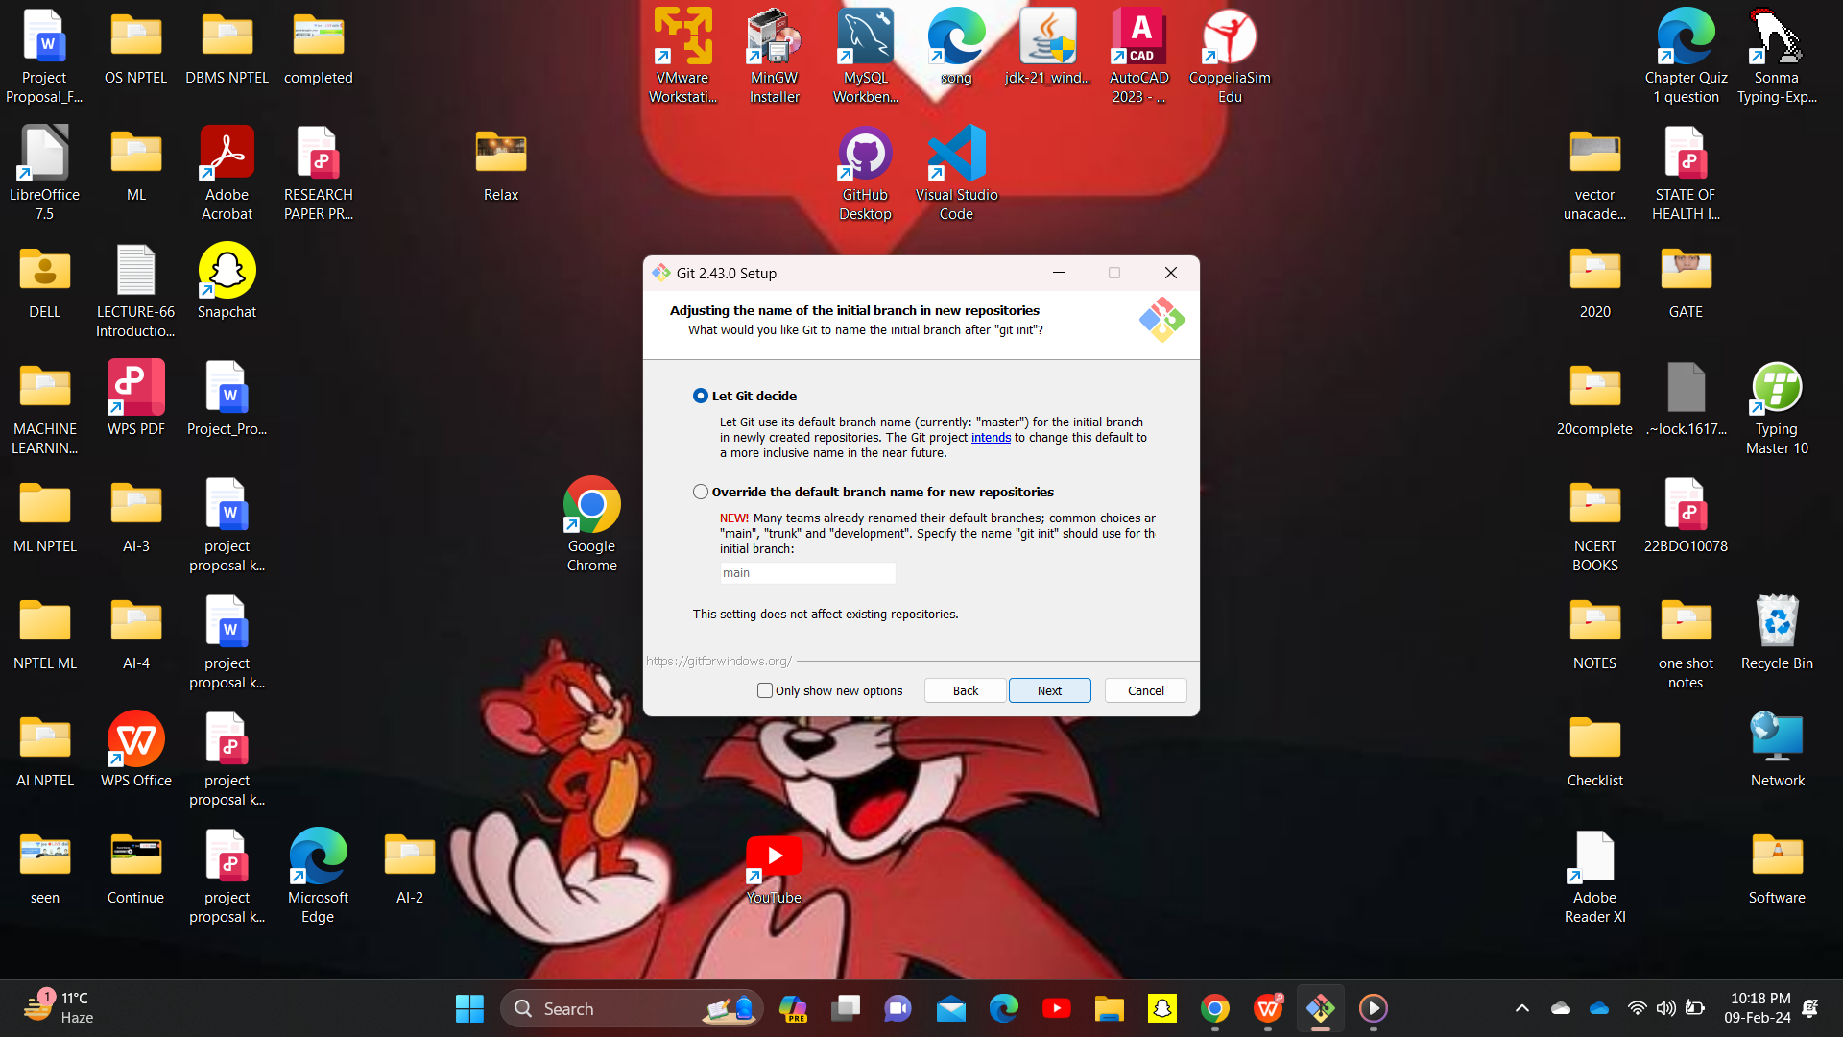

**10)**Adjusting the path environment.

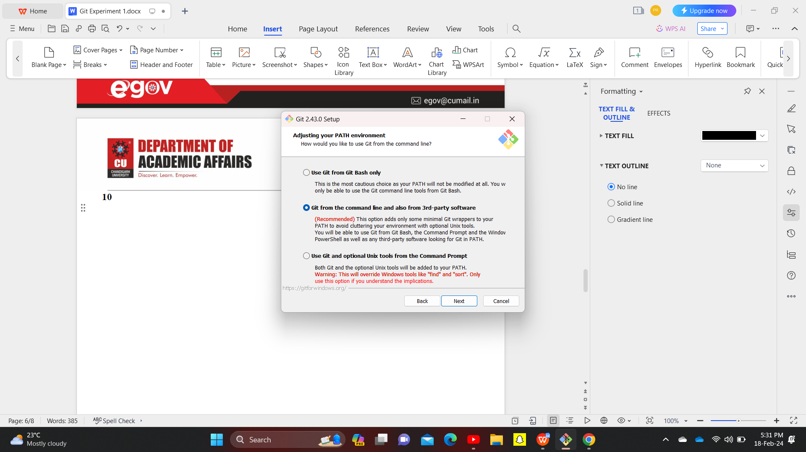

11)Choosing the ssh executable.

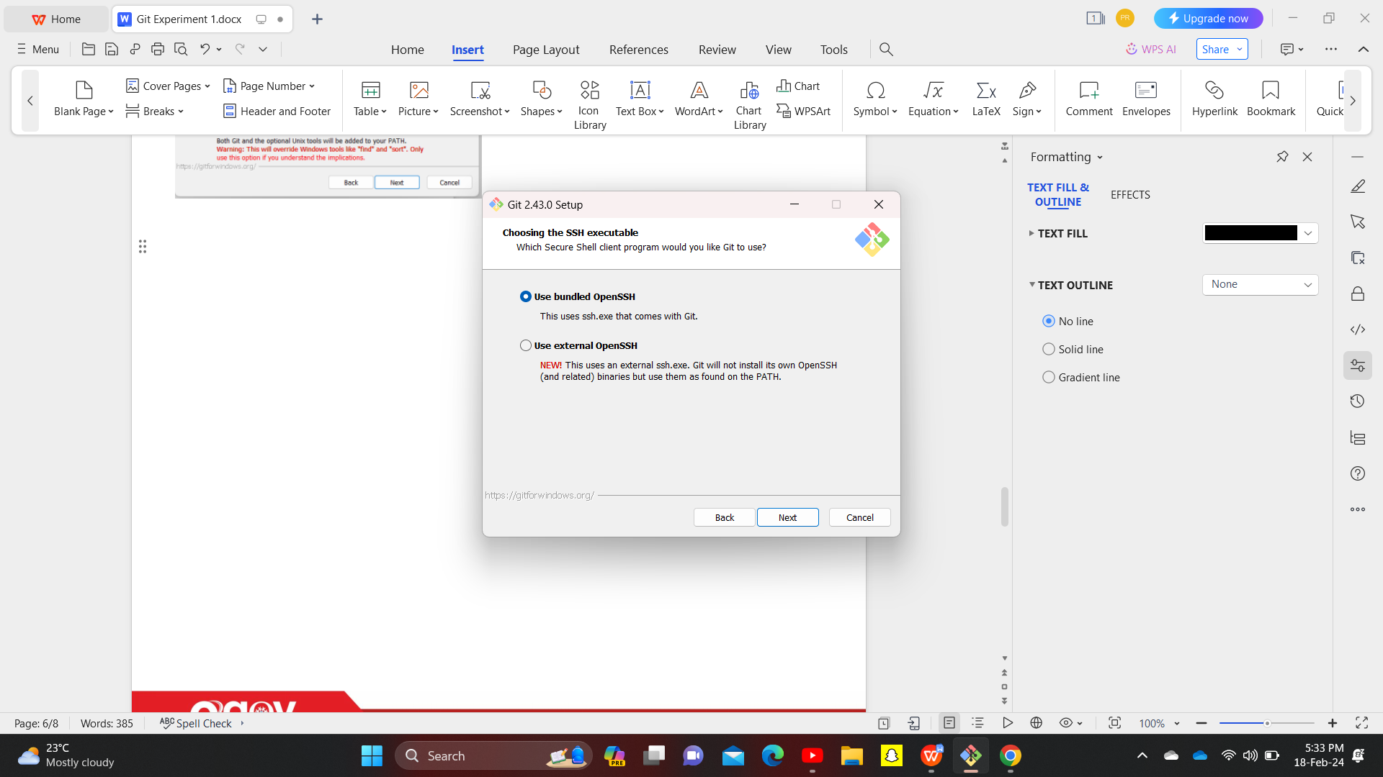

**12)**which SSL/TLS library would you like to use for HTTPS connection.

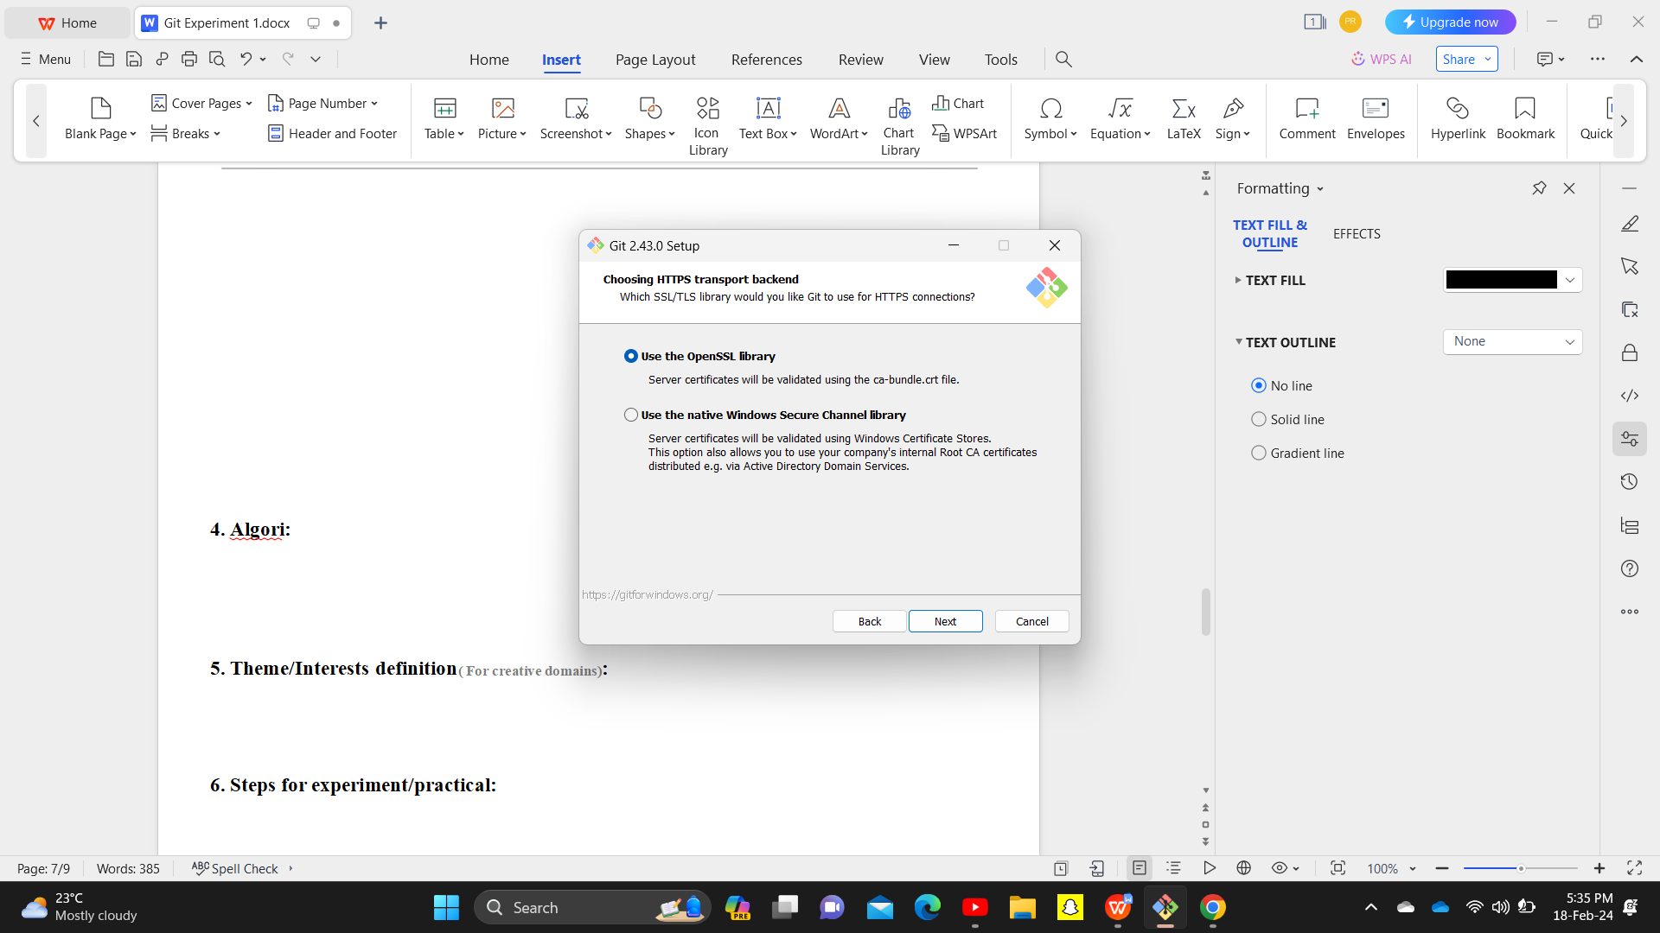

**13)**configuring the line ending conversions.

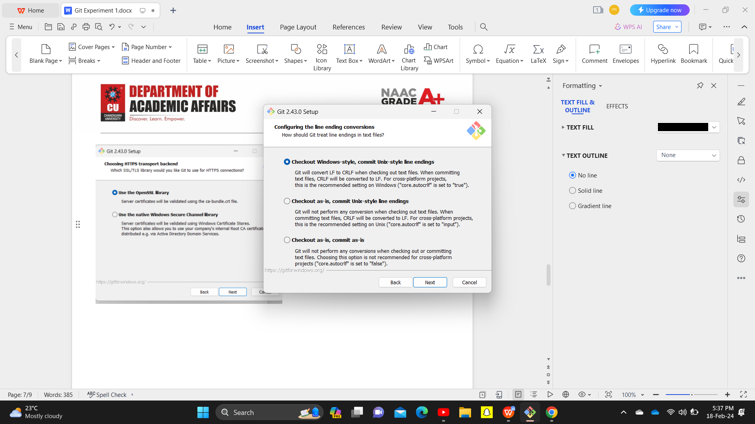

**14)**

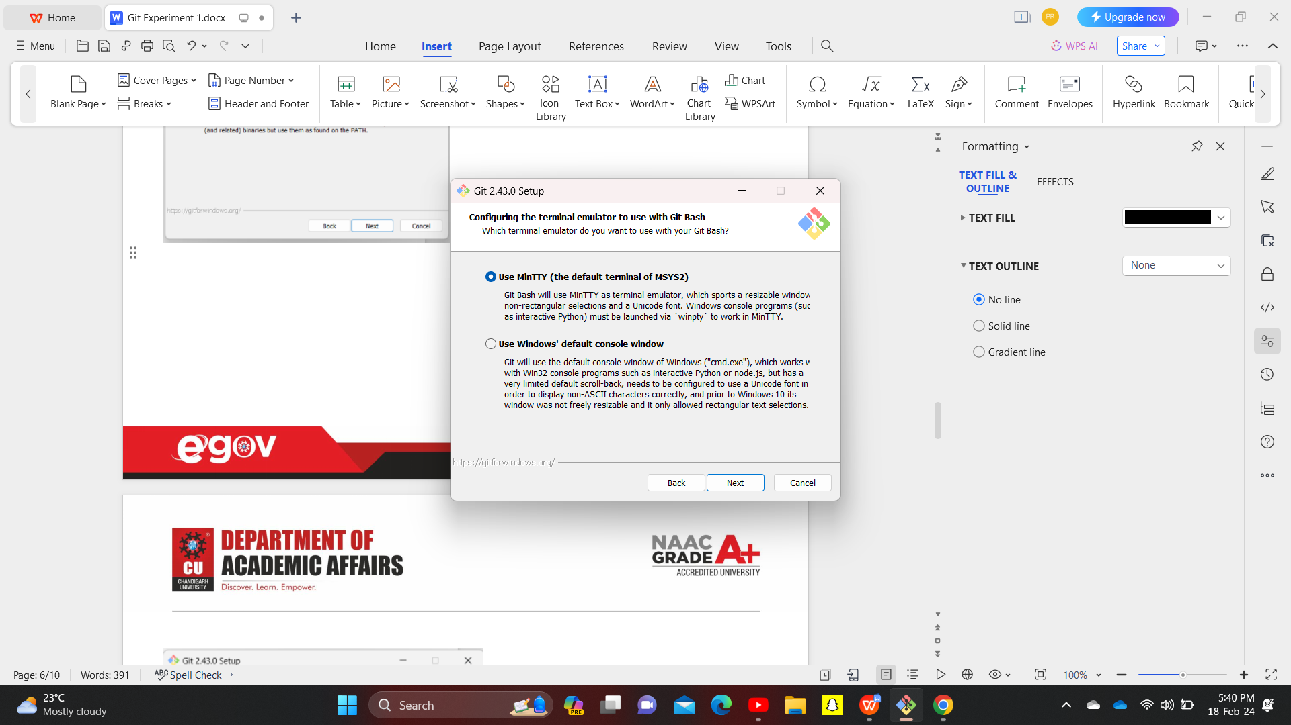

15)Choose the default behaviour of ‘git pull’.

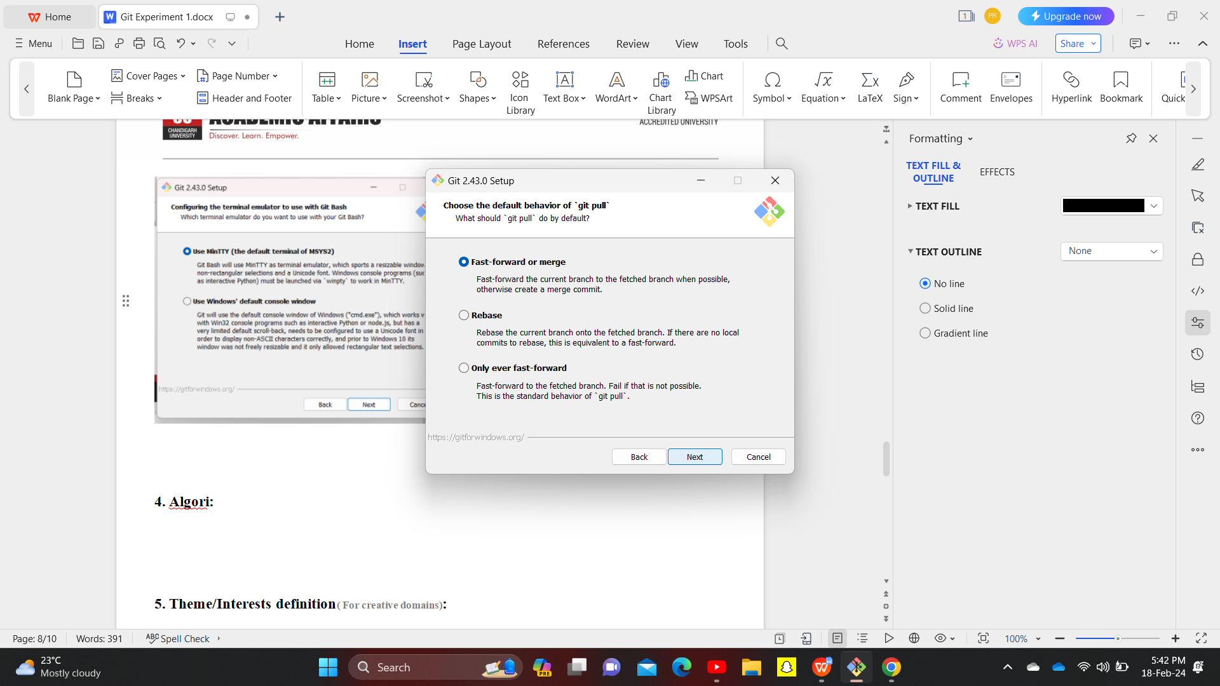

16)Choose a credential helper.

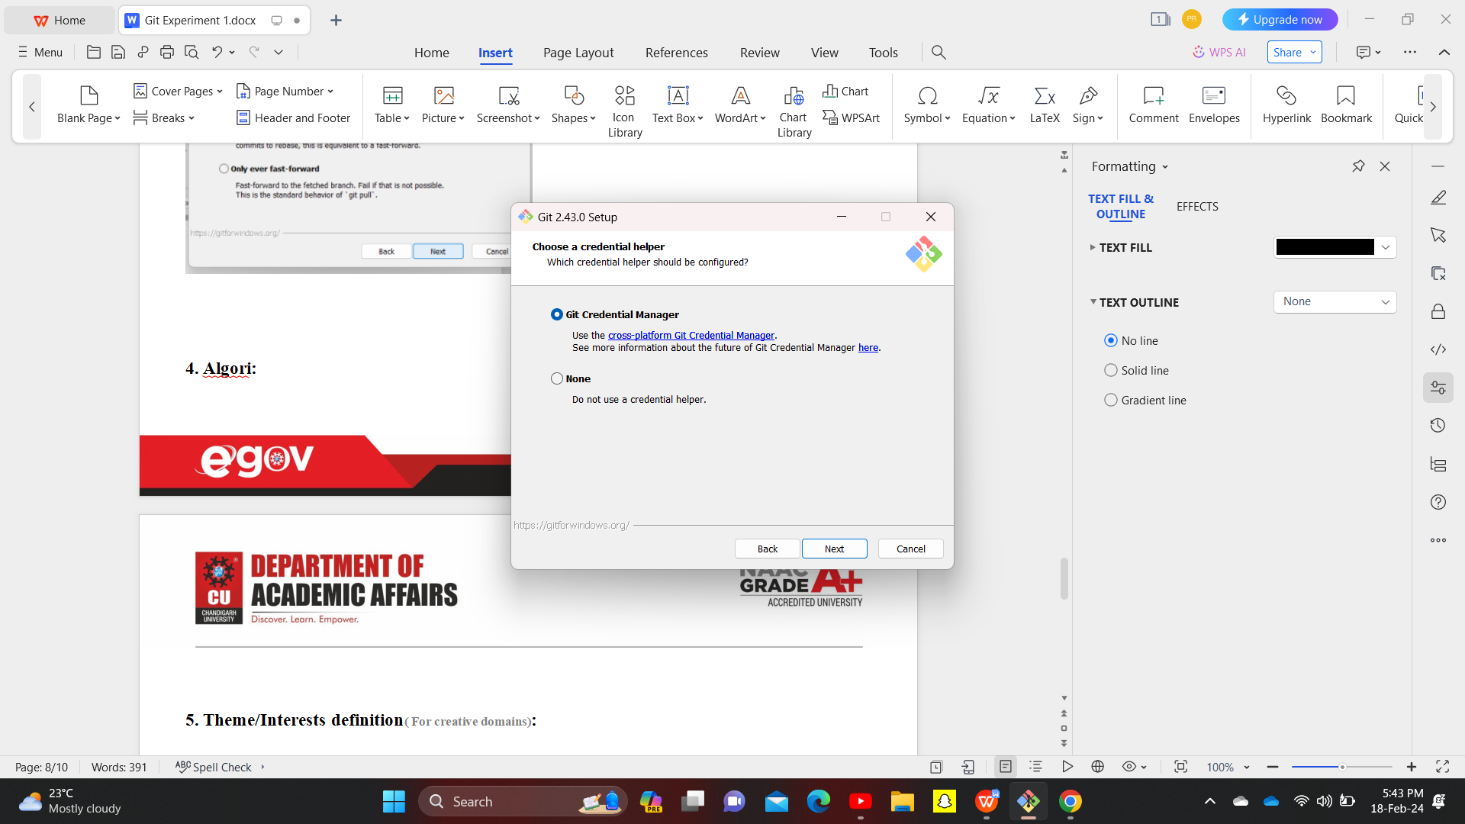

17)Configuring extra options.

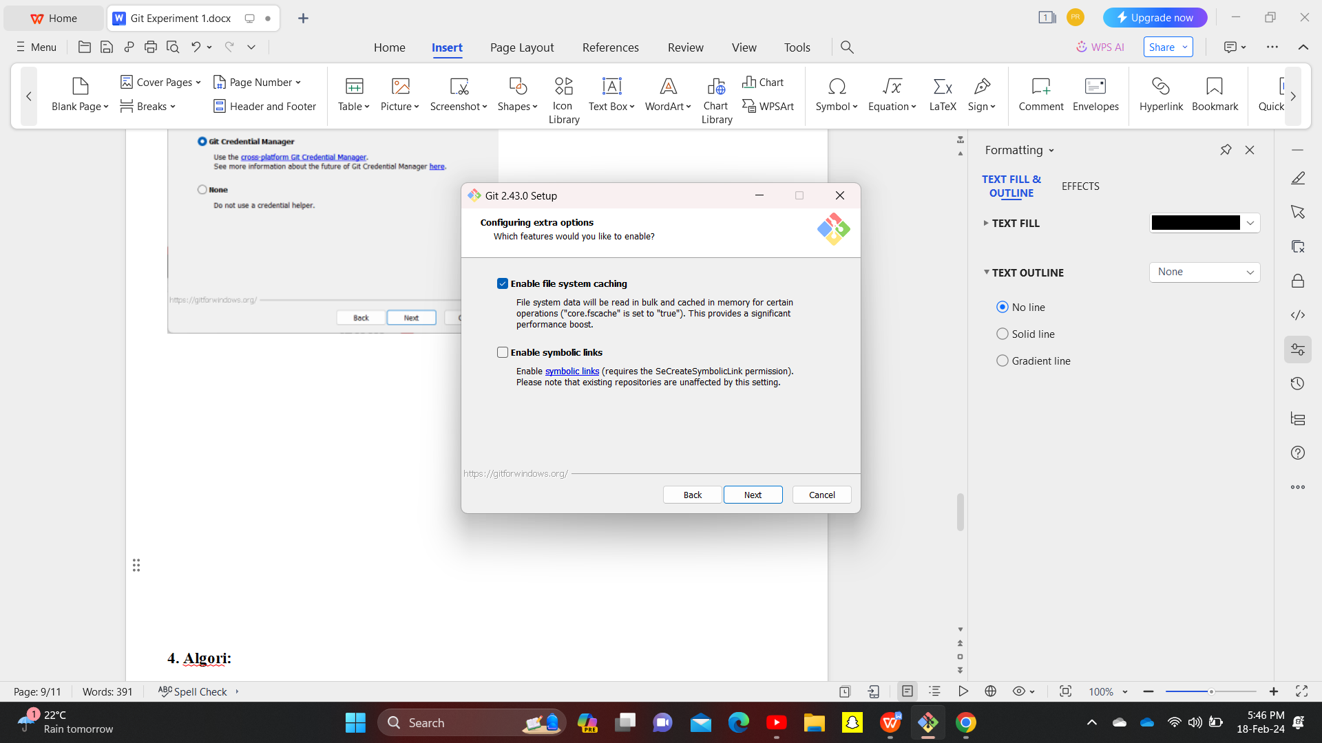

18)Configuring experimental options.

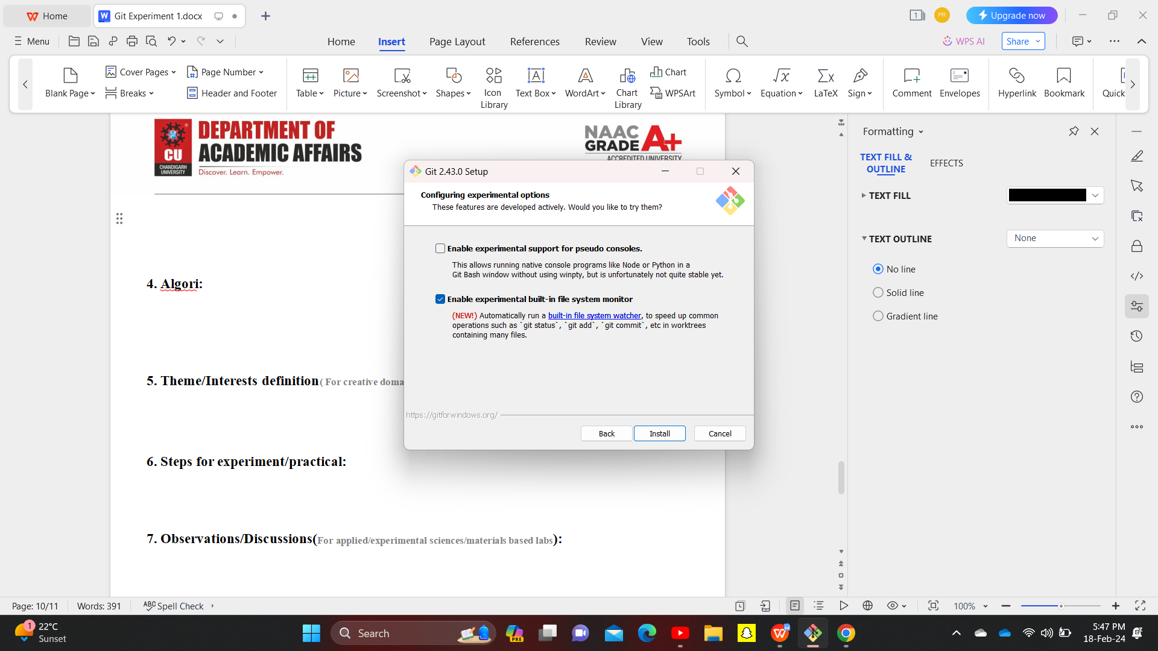Click install

**19)INSATALLING.**

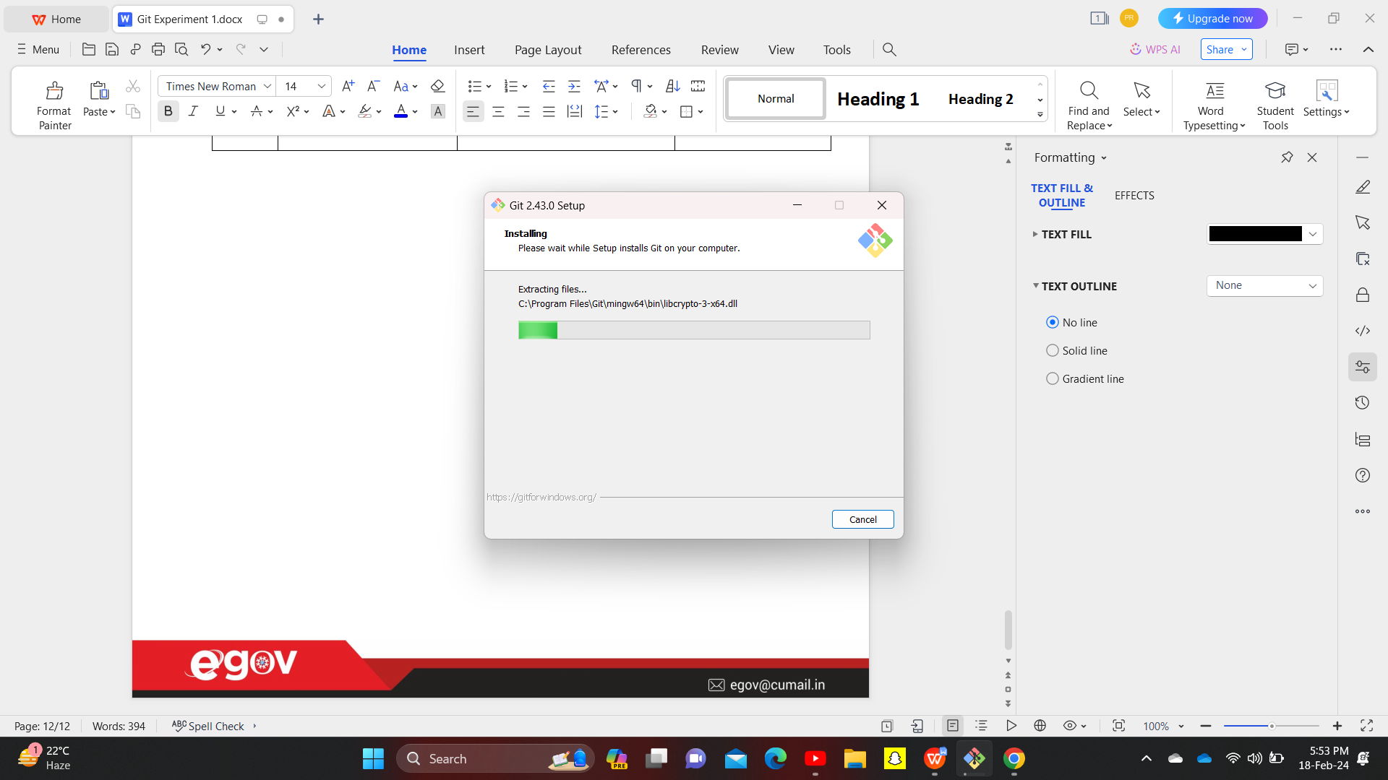

20)Launching of application by selecting installed shortcuts.

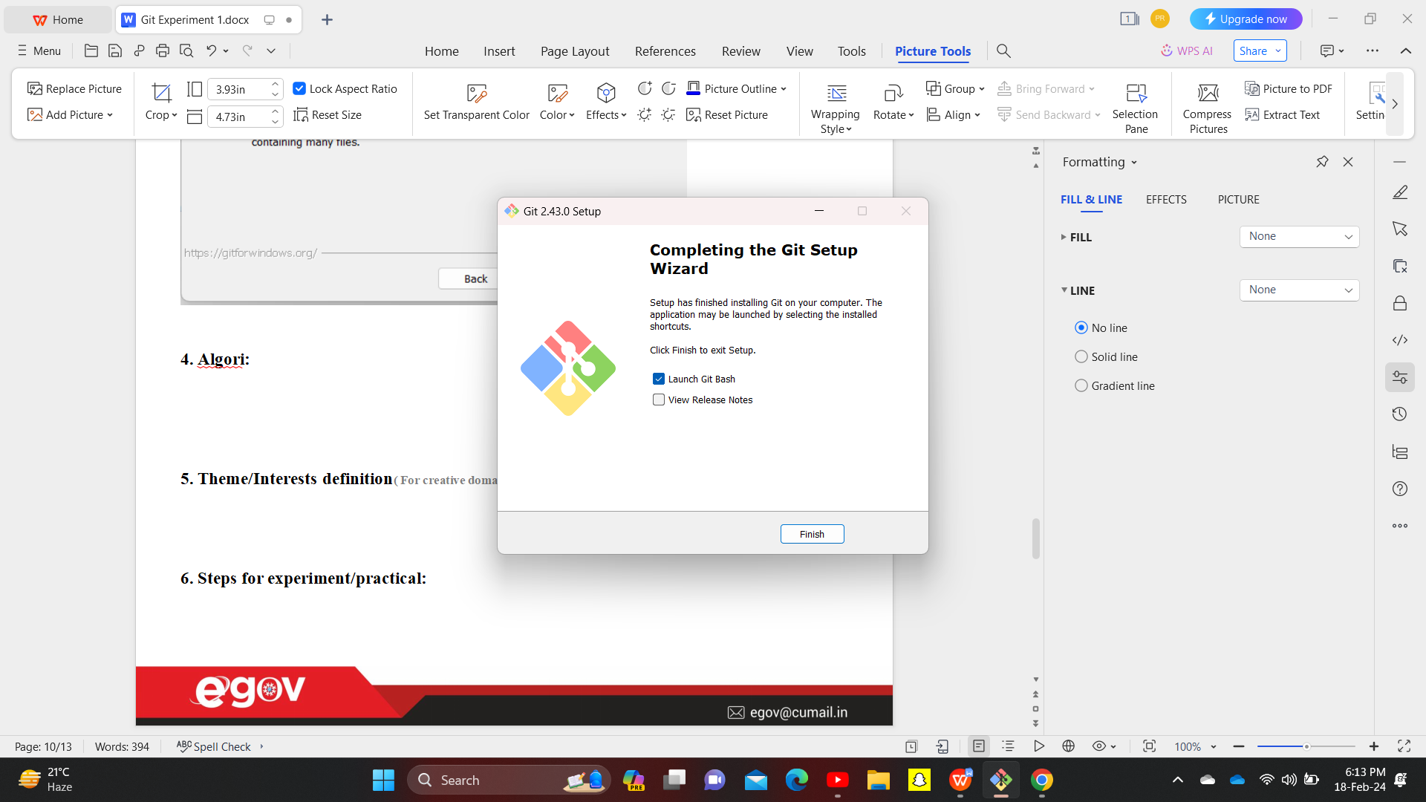

(Git Bash is a terminal, like power shell in window(path is different here),linux/ubuntu.)

After launching , Now its time to work on it.

Git Can be used in two different ways

1. CLI : Command line interface.(Here , user give command like git init, git status)
2. GUI : Graphic User Interface.(Here, user work by clicking through mouse)

21)Here I’m working throuh Git Bash

Whenever we use terminal/CLI ,it always work inside any directory(folder).

For eg c --> users-->project

1. If want to see where it is currently use command

Pwd(present working directory).

1. To change folder we use command cd
2. To see status we use command Git Status.

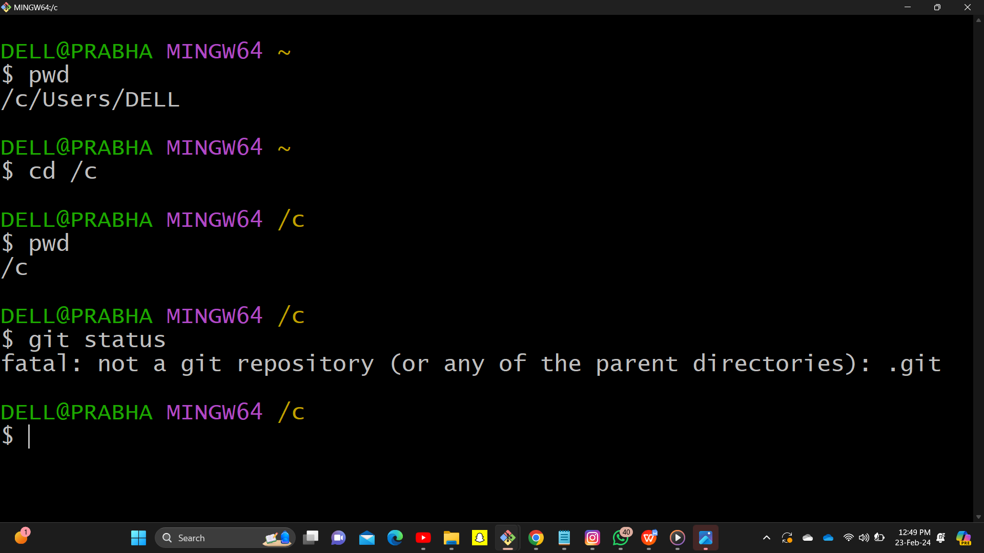

Till now we haven’t created any repository that’s why message is not a git repository…

These are linux based command.

1. Now, do the User setup means I’m telling Git who I am and my E-mail So that During Commit it can take the information of user So in further if I pulll Now I come in one blank directory(now whatever I do in cli it work my repository to any server and if anyone want to contact then they can.

A)For configuring name command is

Git config --global user.name “Name”

B)For Configuring E-mail command is

Git config --global user.email “email id”.

C)If I want to see what are the things we have configured till now we can use command

Git --list

Or individually I can see through command

$ git config user.name

$git config user.email

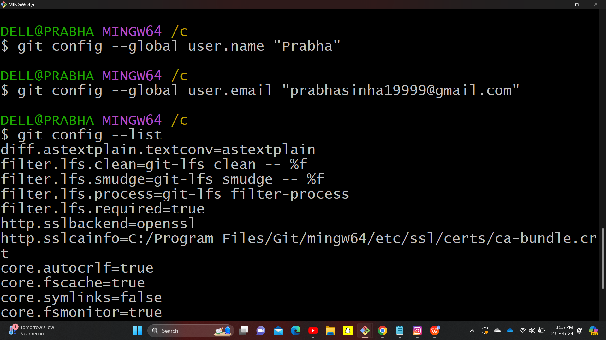

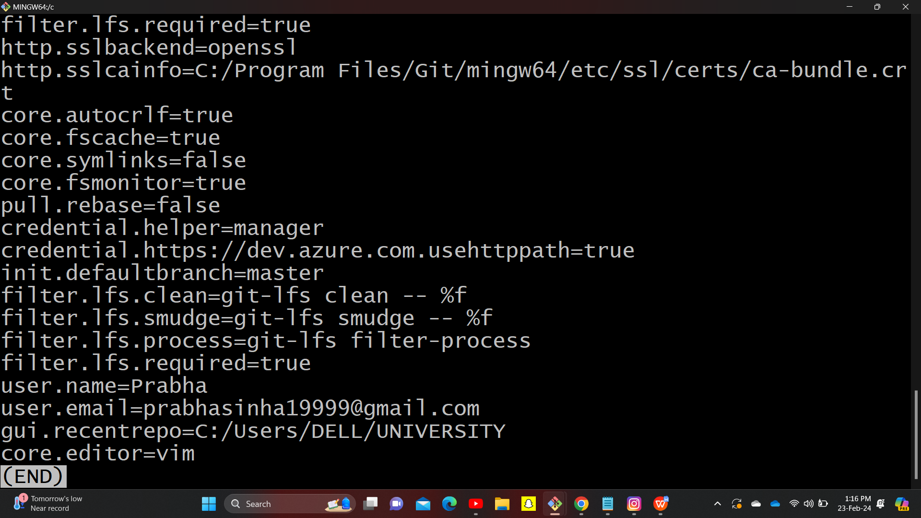

23)Till now we have configured our git, now want to make repository.

Go to/Create any directory of pc for eg.we have created a directory in C named Git Tutorial Sample Practise and now Let’s create 3 file in it a) simple text file and named it first

1. created a document to access data
2. c)created excel document.

Now I want to track repository .

Shift + double click --> Git Bash

Command : git status (to check status of any folder)

Message : not a git repository (or any of the parent directories)

Means it is not a repositry so we want to make this directory as repository to track this directory,

**For this we use command**

$ git init

Message : c:| Git Tutorial Sample practice /.git

Means now my this directory become git repository in which there are 3 files. Now its git responsibility to track all these files

**and one .git folder is also get created.**

Now if we use command git status we can see tracking has started.

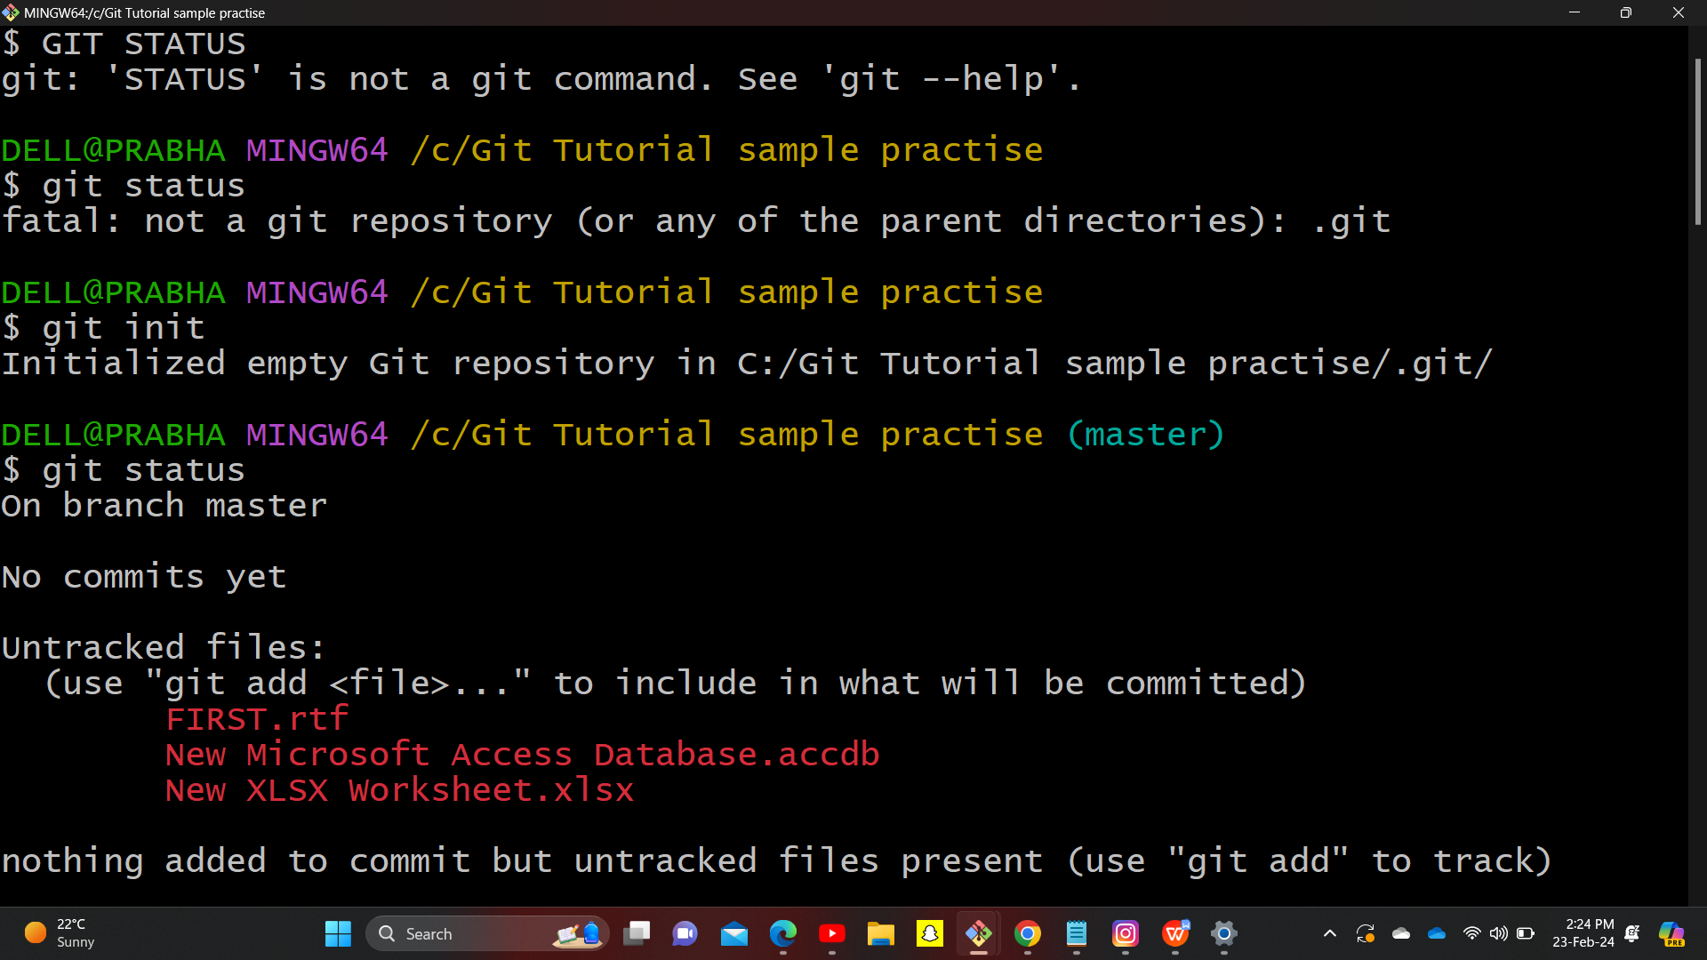

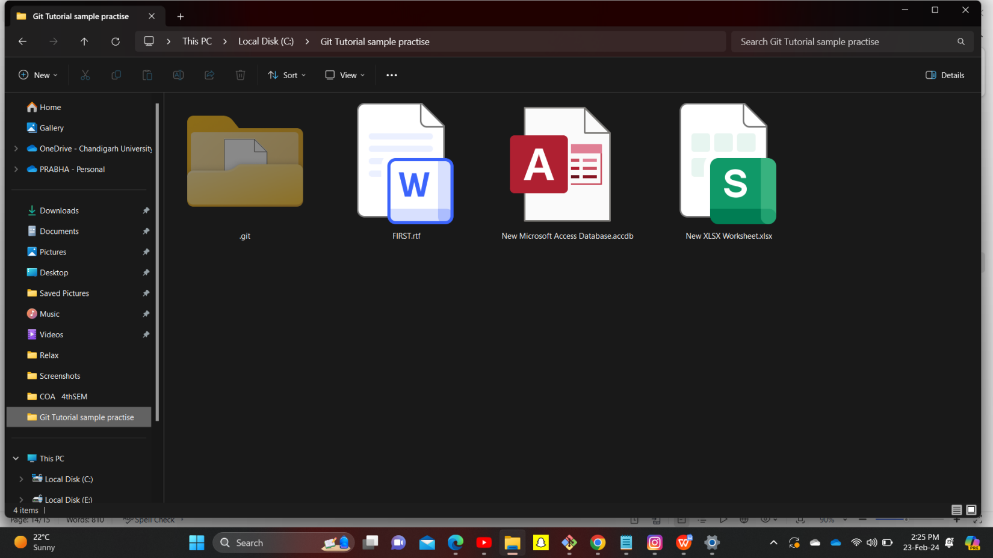

NO commit yet , obviously we havn’t done any commit yet but

Some file are there which we haven’t track with there name and extension in red colour.

24)If I want to add all files I’ll use command

$ git add --a

(--a means all)

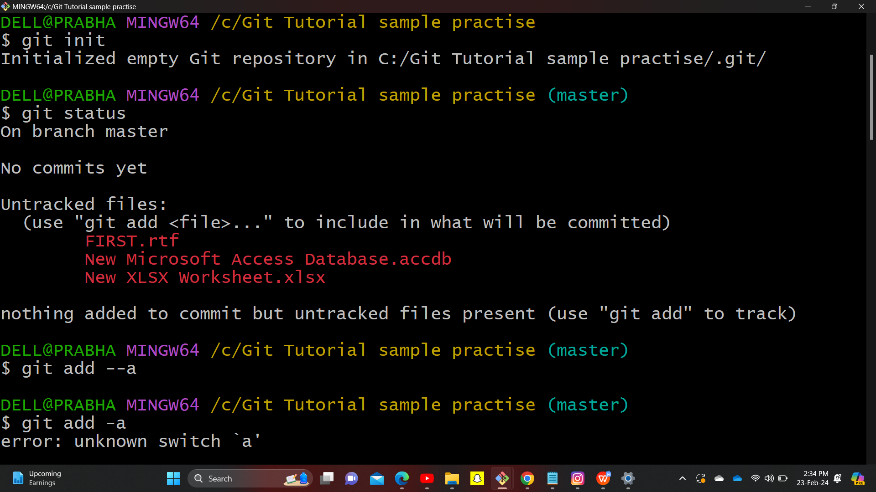

**Now if we check status**

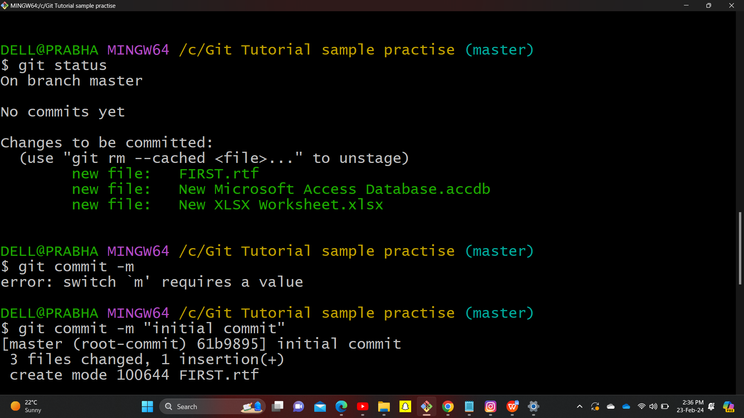

Then it become,come changes to commited from untrackked files and all file with their extension come in green. Means now I’m in staging area with some changes (here it is new) .

And now if we commit all these three file will get commited means snapshot get created.

1. For commit the command is

$ Git commit -m “message”

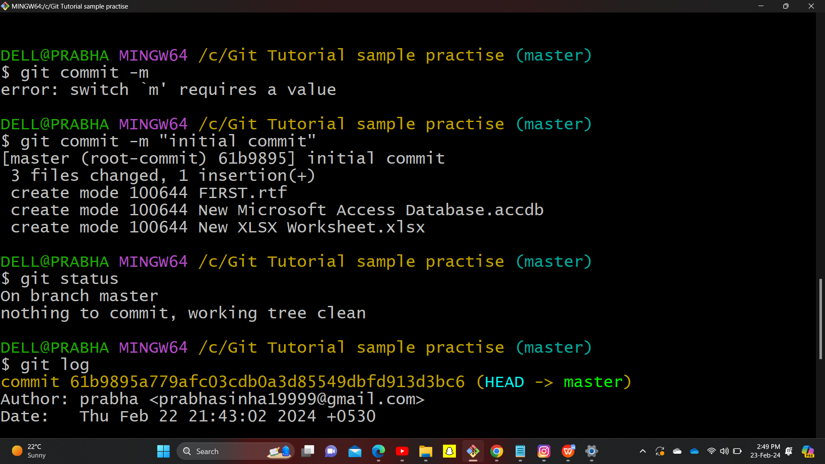

**$ git status**

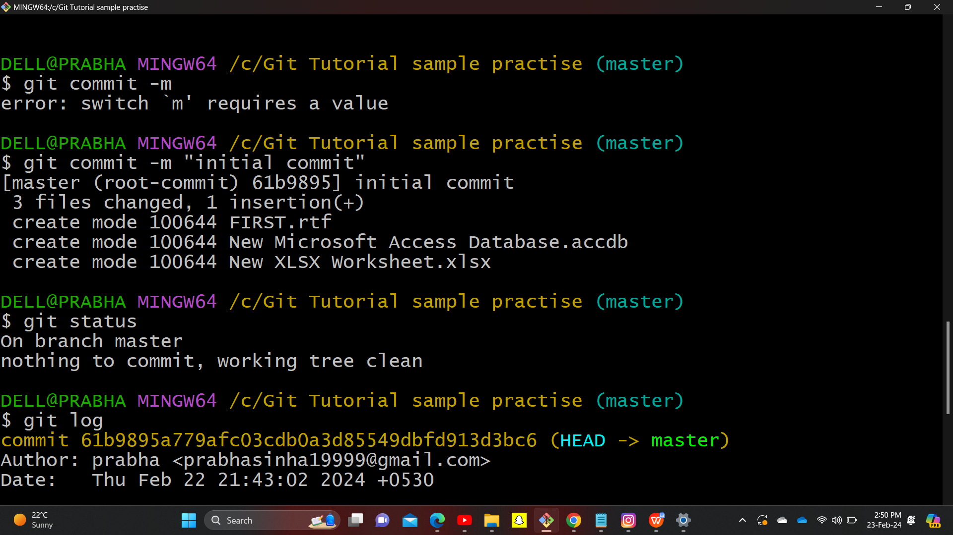

I’m getting proper tracking of my Created repository.

Steps for creating repository on Github.

1. Visit website of GitHub, after logging in ,Go on + mark sign on upper right side,click on it.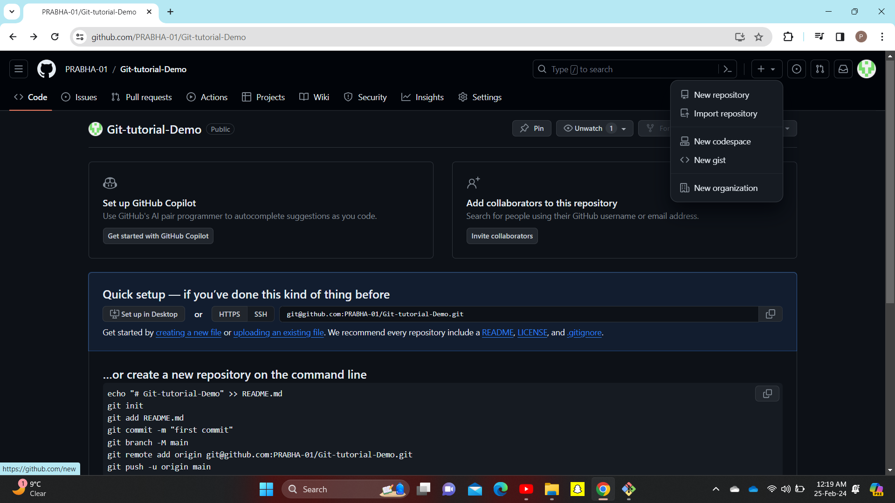

Click on New Repository.

New page appear, fill the repository name you want to give , followed by description of repository followed by public and private.Then click on create.

New Repositry get created.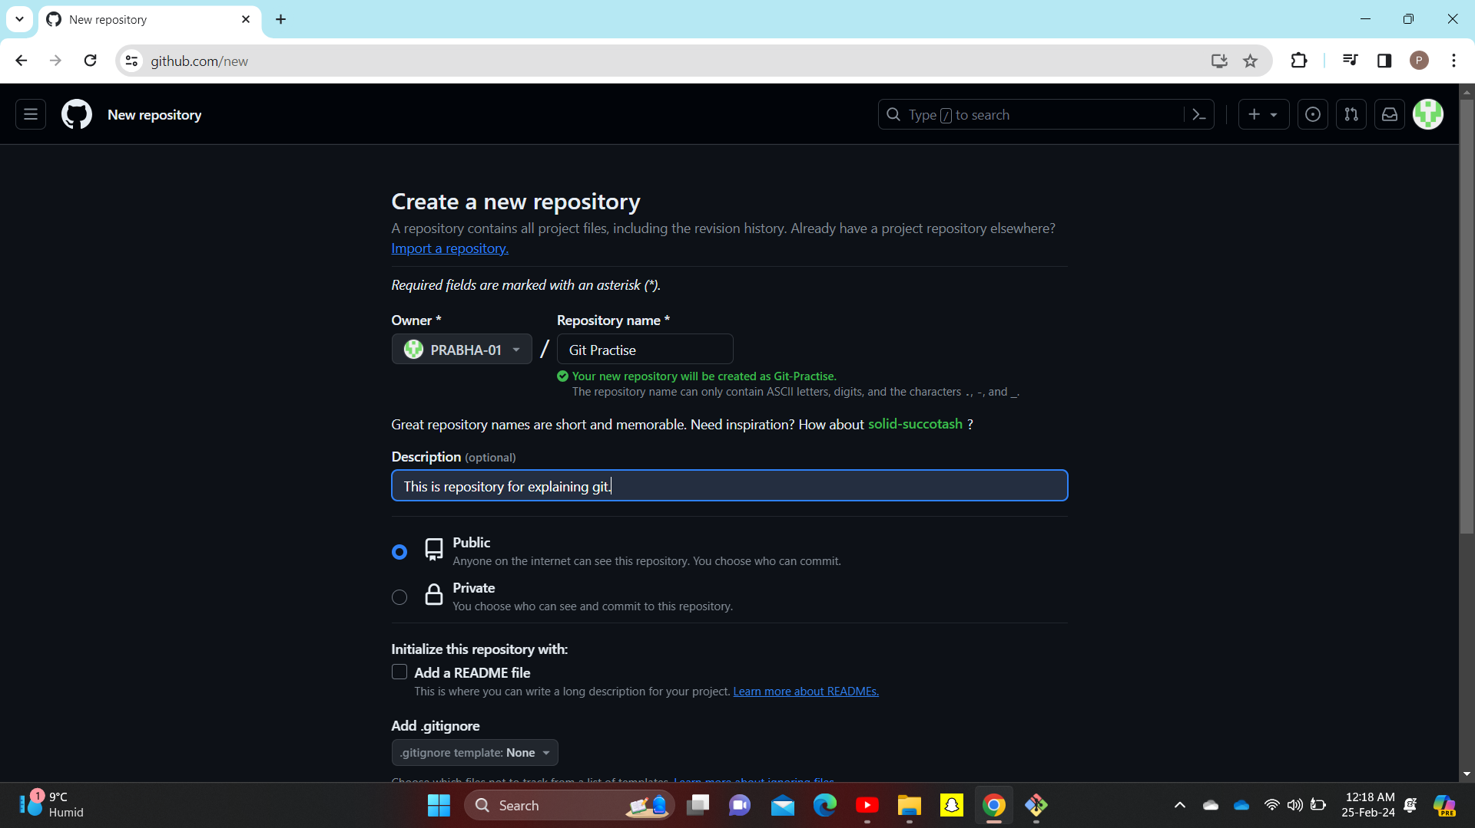

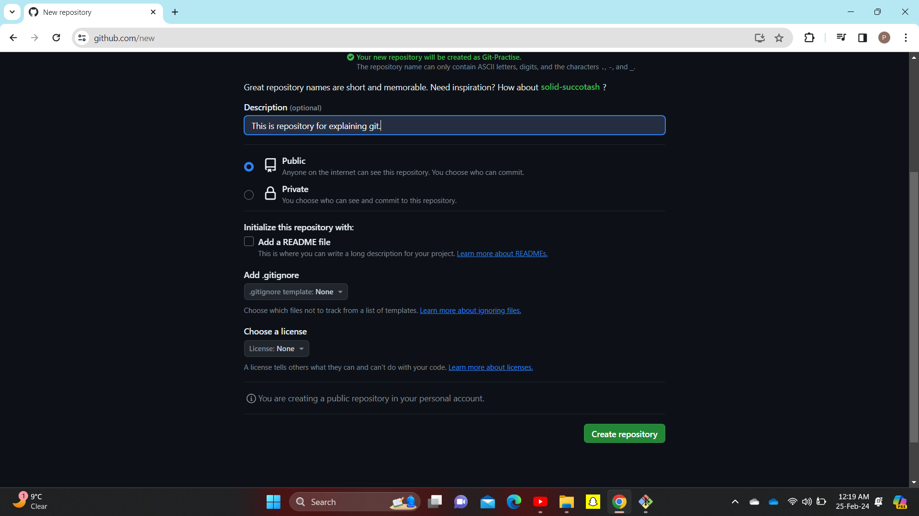

**Repositry is created.**



**COMPLETE**